You are given a **0-indexed** m x n binary matrix land where a 0 represents a hectare of forested land and a 1 represents a hectare of farmland.

To keep the land organized, there are designated rectangular areas of hectares that consist **entirely** of farmland. These rectangular areas are called **groups**. No two groups are adjacent, meaning farmland in one group is **not** four-directionally adjacent to another farmland in a different group.

land can be represented by a coordinate system where the top left corner of land is (0, 0) and the bottom right corner of land is (m-1, n-1). Find the coordinates of the top left and bottom right corner of each **group** of farmland. A **group** of farmland with a top left corner at (r1, c1) and a bottom right corner at (r2, c2) is represented by the 4-length array [r1, c1, r2, c2].

Return *a 2D array containing the 4-length arrays described above for each* ***group*** *of farmland in* land*. If there are no groups of farmland, return an empty array. You may return the answer in* ***any order***.

**Example 1:**

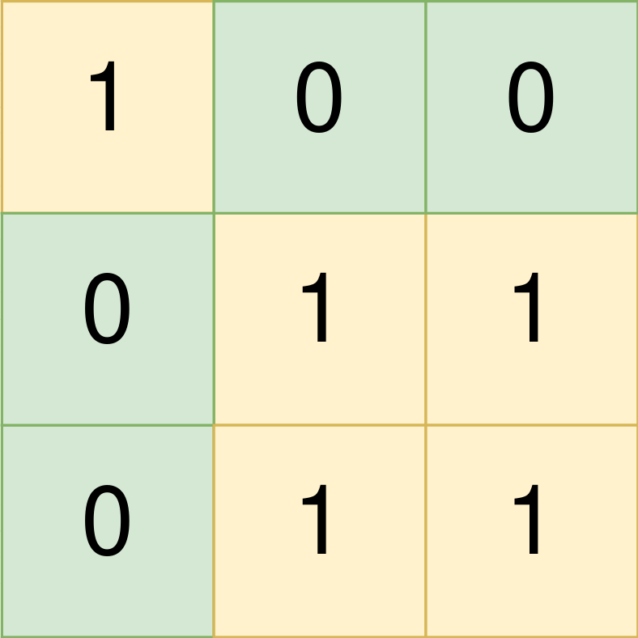

Input: land = [[1,0,0],[0,1,1],[0,1,1]]  
Output: [[0,0,0,0],[1,1,2,2]]  
Explanation:  
The first group has a top left corner at land[0][0] and a bottom right corner at land[0][0].  
The second group has a top left corner at land[1][1] and a bottom right corner at land[2][2].

**Example 2:**

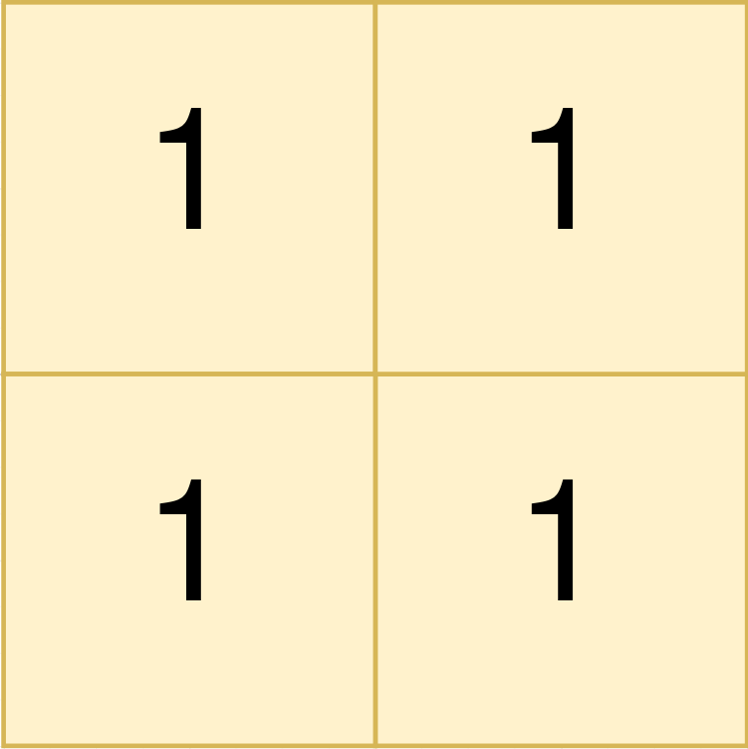

Input: land = [[1,1],[1,1]]  
Output: [[0,0,1,1]]  
Explanation:  
The first group has a top left corner at land[0][0] and a bottom right corner at land[1][1].

**Example 3:**

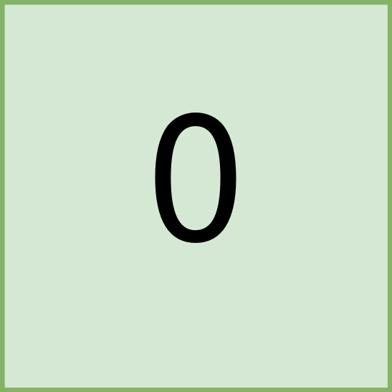

Input: land = [[0]]  
Output: []  
Explanation:  
There are no groups of farmland.

**Constraints:**

* m == land.length
* n == land[i].length
* 1 <= m, n <= 300
* land consists of only 0's and 1's.
* Groups of farmland are **rectangular** in shape.